Library Management System

Software Requirements Specification

**Table of Contents**

**1. INTRODUCTION**

1.1 PURPOSE

1.2 SCOPE

1.3 DEFINITIONS, ACRONYMS, AND ABBREVIATIONS

**2. GENERAL DESCRIPTION**

2.1 PRODUCT PERSPECTIVE

2.2 PRODUCT FUNCTIONS

2.2.1 USER INTERFACE

2.2.2 LIBRARY USER ACCOUNT MANAGEMENT SYSTEM

2.2.3 BOOK ISSUE SYSTEM

2.2.4 BOOK RETURN

2.2.5 DATA ENTRY

2.2.6 ADMINISTRATOR

2.2.7 USERS (LIBRARY MEMBERS)

2.2.8 REPORT GENERATION

2.3 USER CHARACTERISTICS

2.4 GENERAL CONSTRAINTS

2.5 ASSUMPTIONS AND DEPENDENCIES

**3. SPECIFIC REQUIREMENTS**

3.1 SOFTWARE REQUIREMENTS

3.2 HARDWARE REQUIREMENTS

3.3 FUNCTIONAL REQUIREMENTS

3.4 DESIGN CONSTRAINTS

**4. DIAGRAM**

4.1 ER DIAGRAM

4.2 USE CASE DIAGRAM

4.3 SEQUENCE DIAGRAM

4.4 CLASS DIAGRAM

**1. Introduction**

The Library Management System (LMS) aims to provide an efficient and user-friendly platform for managing library resources, operations, and services. This system will facilitate librarians and library patrons in tasks such as book search, borrowing, returning, and administrative functions like inventory management, user management, and reporting.

**1.1 Purpose**

The purpose of this Software Requirements Specification (SRS) document is to provide a comprehensive understanding of the functionalities, constraints, and requirements of the Library Management System. It serves as a blueprint for the development team to design, implement, and test the system effectively. Additionally, it provides stakeholders with a clear overview of the system's scope and features.

**1.2 Scope**

The Library Management System will include modules for both librarians and patrons, offering features such as:**User Management**: Registration, authentication, and profile management for librarians and patrons.

**Catalog Management**: Adding, updating, and deleting library resources such as books, journals,, etc., along with metadata like titles, authors, genres, and ISBN numbers

.**Borrowing and Returning**: Facilitating the borrowing and returning process, including issuing due dates, managing fines, and notifications for overdue items.

**Search and Discovery**: Enabling users to search for library resources based on various criteria such as title, author, keyword, or category.

**Reservation**: Allowing patrons to reserve items that are currently unavailable and notifying them when the items become available.

**Reporting**: Generating reports on library usage, inventory status, overdue items, and other relevant metrics for administrative purposes.

**Security**: Implementing robust security measures to protect user data, ensure confidentiality, and prevent unauthorized access.

**1.3 Definitions, Acronyms, and Abbreviations**

**LMS:** Library Management System

**SRS:** Software Requirements Specification

**ISBN:** International Standard Book Number

**API:** Application Programming Interface

**UI:** User Interface

**SQL:** Structured Query Language

**ER:** Entity Relationship

**2. General Description**

The General Description section provides an overview of the Library Management System, outlining its purpose, scope, key features, constraints, assumptions, and dependencies. This information lays the groundwork for the detailed specifications outlined in subsequent sections of the Software Requirements Specifications(SRS) document.

**2.1 Product Perspective**

The Library Book System is used for Library Manager, Librarian, and Library User. The system is self-contained. However, it is possible to exchange data with other system through external interface if required. The following is a typical system diagram:

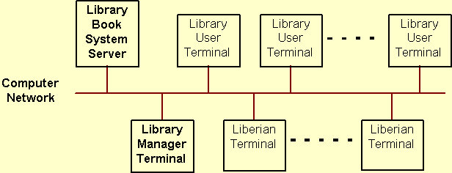

**2.2 Product Functions**

**2.2.1 User Interface**

The user interface requirements are concerned with the user interface and how information is presented to the user.

**2.2.2 Library user account management system**

* The system shall display the user account information including user ID,last and first name and user position.
* The system shall use a graphic user interface which allows librarians to choice actions including adding, removing, changing and adding user account information.

**2.2.3 Book Issue System**

When check out the books, the system shall show all the book borrowing information about a particular user including:

* the first and last name of the user
* the student card number.
* if the user has unpaid penalty
* the number of books the user has not return.

When check out the books, when required by librarians, the system shall show the information about books which is borrowed before and not returned yet including:

* the ISBN of the book
* the title of the book
* the borrowing and due date of the book
* the branch which the book is checked out.

**2.2.4 Book return**

* When recalling the book, the system shall display a list of all the copies of the book which is borrowed out ordered by book lend out time.
* When the recalled book is arrived, the system shall display the last and first name, the recall date and the arriving date of the book.

**2.2.5 Data Entry**

The data entry requirements are concerned with how data is entered and validated.

* The system shall allow a user to enter his/her data via a keyboard or choose an item via a mouse.
* Whenever the "date" data is needed, it shall be entered only by choose date from an online calendar.
* The system shall allow the user to enter the student card number and ISBN both by typing or scanning.
* The system shall allow the user to enter book borrowing, recalling data as frequently as required.

**2.2.6 Administrator**

* Admin should be able to insert, modify and delete books.
* Can accept or reject a new user according to the library Policy or payment methods.
* Increase the period for borrowing a book for specific type or group of users.
* Can get the information (status report) of any member who has borrowed a book.
* Add and edit book categories and arrange books by categories.
* Add and edit authors and publishers information.
* Can send lateness warnings to people who have exceeded deadline date.
* Can record books returned by users.

•Can accept or reject a new user according to the library policy or payment methods.

•Increase the period for borrowing a book for specific type or group of users.

•Can get the information (status report) of any member who has borrowed a book.

•Add and edit book categories and arrange books by categories.

•Add and edit authors and publishers information.

•Can send lateness warnings to people who have exceeded deadline date.

•Can record books returned by users.

**2.2.7 Users( Library Members)**

* The member should be provided with the updated information about the books catalogue.
* Members are given a provision to check their account’s information and change it.
* Members have the ability to search through books by subject, title, authors, or any information related to the book.
* Can extend the period of borrowing book to be brought to the library book collection.

**2.2.8 Report Generation**

* The system shall have a report feature that will allow the user to generate a report showing the information of all the sign out book in a time period which is the search criteria input by user. The information includes the number of books, the time period and the information is grouped by book categories.
* The system shall have a report feature that will allow the user to generate a report showing the information about all the users who have overdue books and penalty.
* The system shall have a report feature that will allow the user to generate a report showing the information of a particular patron.
* The system shall have a report feature that will allow the user to generate a report showing the information of book purchase information in a period including the book titles, category, the author, the publisher, the price. It also shall give statistic data about the total number of books purchased, the money paid by category.
* The system shall be generate those reports to the display, a file or a printer which is linked to the system.

**2.3 User Characteristics**

The three types of user for the Library Book System are:

* Library Manager
* Librarian
* Library User

The following table describe general users characteristics that will affect the functionality of the software product.

|  |  |  |  |
| --- | --- | --- | --- |
| **Type of User** | **User Characteristic** | **User Technical Expertise** | **How the user characteristic and technical expertise affect Library Book System Functionality** |
| Library Manager | * Good understanding to library operation. * Responsible for library staff managing. | * Average in technical proficiency. | * User interface with less input steps. * Easy to learn. |
| Librarian | * Good understanding to library operation. * Responsible for library operation | * Average in technical proficiency | * User interface with less input steps. * Easy to learn. |
| Library User | * Diverse User Characteristic * Younger generation tends to accept and learn new thing easier than older generation. | * Younger generation has a lot of exposure to Windows type application. | * GUI interface may be easier to learn than text interface. * Provide system help. * Provide appropriate error messages for invalid user inputs. |

**2.4 General Constraints**

* The information of all users, books and libraries must be stored in a database that is accessible by the website.
* MS SQL Server will be used as SQL engine and database.
* The Online Library System is running 24 hours a day.
* Users may access LMS from any computer that has internet browsing capabilities and an internet connection.
* Users must have their correct usernames and passwords to enter into their online accounts and do actions.

**2.5 Assumptions and Dependencies**

The success of this system depends on

* Existence of an internet service to all people.
* Are librarians and users comfortable with computers and have enough ability to work with thee product ?
* Website interface must be friendly and easy-to-use.
* The search mechanism should be simple and fast.
* The system must be scalable to accommodate a large number of users and library resources.
* It should adhere to industry standards for data security and privacy.

**3. Specific Requirements**

**3.1 Software Requirement**

* **Integrated Development Environments (IDEs):**Visual Studio CodeJetBrains IntelliJ IDEA
* **Version Control Systems:**Git
* **Programming Languages:Backend Development:**JavaPython**Frontend Development:**HTMLCSSJavaScript
* **Database Management Systems (DBMS):**Relational Database Management Systems (RDBMS):MySQL

**3.2 Hardware Requirement**

* Operating system : Windows 8/10/11
* Hard disk : 256GB or above
* RAM : 8GB
* Processor : Intel i3/i5/i7

*.*

**3.3 Functional Requirements**

* Book entry: In this module we can store the details of the books.
* Register student: in this module we can keep the details of the new student.
* Book issue: This module is used to keep a track of book issue details.
* Book return: This module enables to keep a track of return the books.

**3.4 Design Constraints**

Each member will be having a identity card which can be used for the library book issue, fine payment etc. whenever library member wish to take a book, the book issued by the library authority will be check both the book details as well as the student details and store it in library database. In case of retrieval of book much of human intervention can be eliminated.

**4.1 ER DIAGRAM**

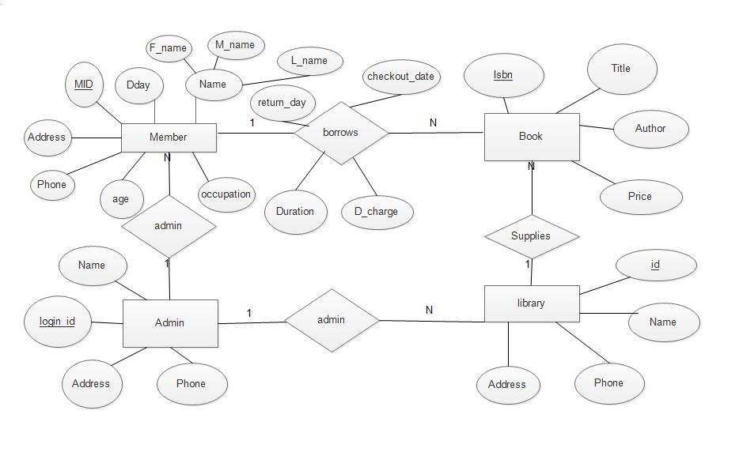

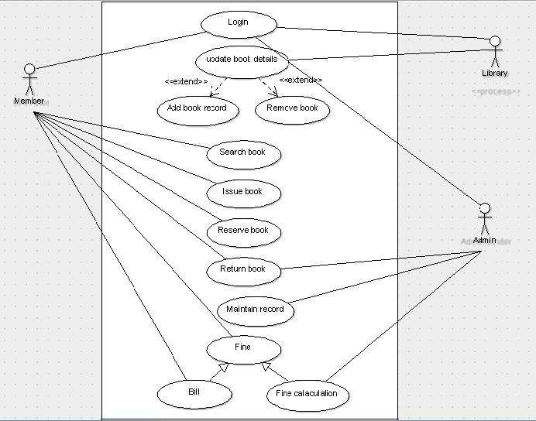**4.2 USE CASE DIAGRAM**

**4.3 SEQUENCE DIAGRAM**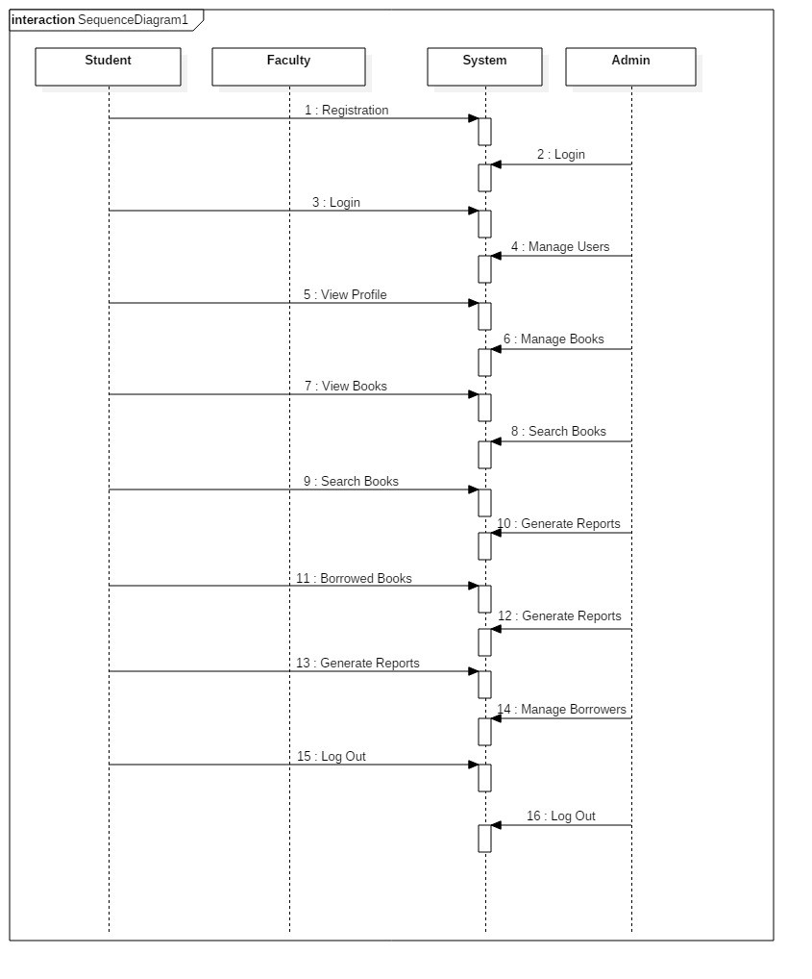

**4.4 CLASS DIAGRAM**

